Sacramento Area 1
Wrestling Championships
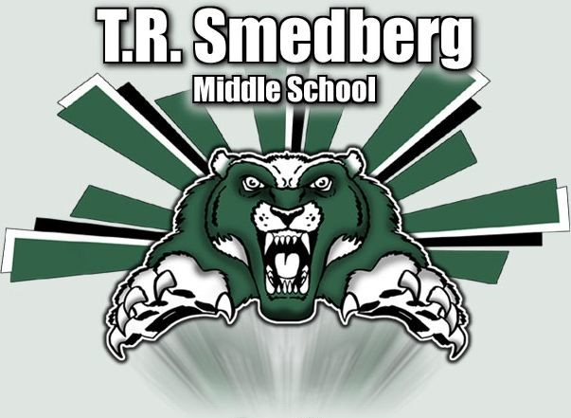
WHEN: | Saturday, February 15, 2019
WHERE: | TR Smedberg Middle School
 | 8239 Kingsbridge Dr., Sacramento, CA 95829
WEIGH-INS: | Thursday, February 13, 2019 4:00 pm – 7:00 pm
 | Smedberg Aux Gym *NO SAT. WEIGH INS*
FORMAT: | Varsity ONLY  Varsity – TOC Weights  62,66,70,76,83,89,95,100,103,108,112,116,122,128,135, 142,153,168,185,205,235lbs  Top 6 finishers in each weight class advance to Regionals 2/22 at Elk Grove HS.
ENTRY FEE: | $15 each wrestler; coaches collect and pay on Saturday
 | (Make checks payable to Sheldon High School Wrestling Booster Club or SHSWBC)
AWARDS: | Team awards for 1st through 3rd place
 | Medals awarded to the top 3 wrestlers in each weight class

COACHES MEETING: Saturday 8:00 am WRESTLING BEGINS: Saturday 9:00 am

RSVP: Send roster and seeding info by Wednesday, February 12, 2019

Contact: Marc Daniels – dmarcdaniels@hotmail.com - 916-919-7445

